Chapter 2: Displaying and Describing Categorical Data

Part IV: The other Bar Charts

**Titanic Example:**

1. **Side by Side Bar Chart:**
2. Open the data file (Titanic 2.csv). In this file, there are a contingency table and a conditional distribution table.
3. Select the range of the data set.

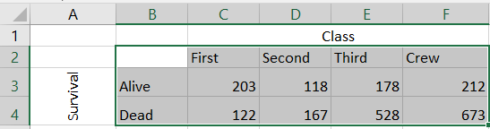

1. Select **Insert** tab $⟹$**Insert Column or Bar Chart $⟹$**  **3 - D** **Column**.

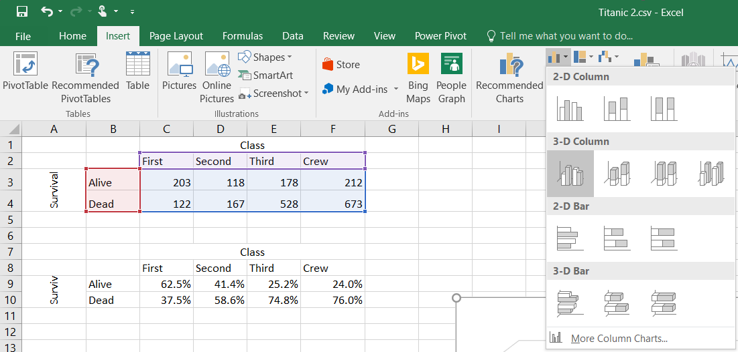

1. The result is

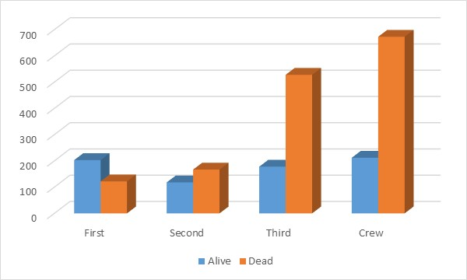

**Note:** you may add titles to X and Y axis. (See Chapter 2 – part 2.)

**Practice:** Create a side by side bar chart for the conditional distribution table.

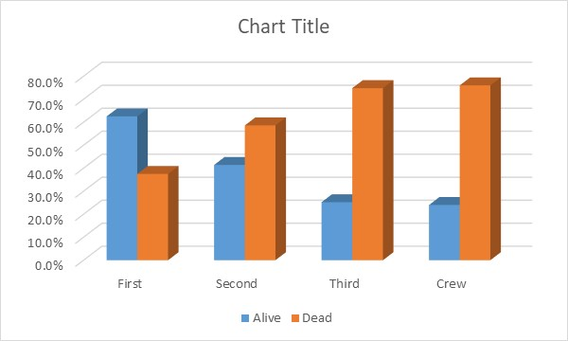

1. **Segmented Bar Chart:**
2. Open the data file (Titanic 2.csv). In this file, there are a contingency table and a conditional distribution table.
3. Select the range of the data set.



1. Select **Insert** tab $⟹$**Insert Column or Bar Chart $⟹$**  **3 - D** **Column**.

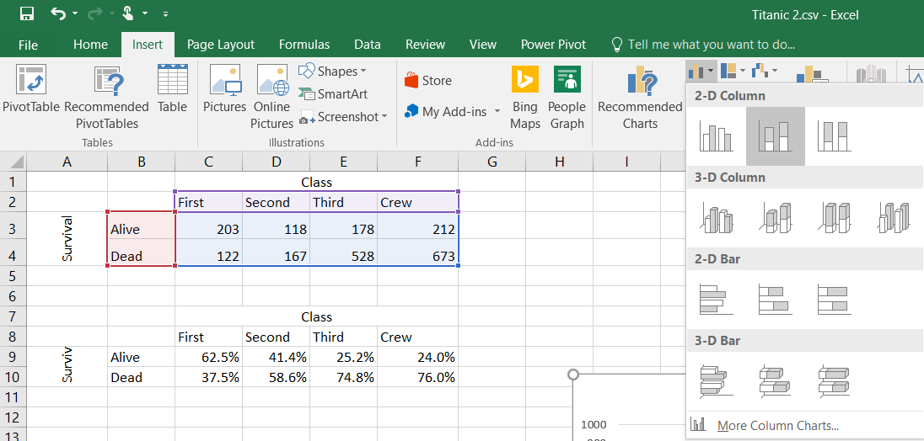

1. The result is

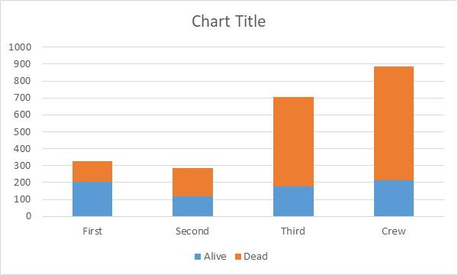

**Note:** we may add titles to X and Y axis. (See Chapter 2 – part 2.)

**Practice:** Create a side by side bar chart for the conditional distribution table.

